

Dear Parent(s)/Guardian:

What an exciting time this is for you and your high school swimmer/diver! I’d like to welcome you and your family to the FBISD Dive Team. I have a very fun-filled season ahead for us, and sincerely look forward to meeting you and getting to know your family better.

This team is a cooperative effort among coaches, divers, and parents; therefore,   
we would like to invite you to contact us through e-mail anytime. In addition, I will be informing you about what is taking place throughout the season through various letters and/or emailing you regarding your diver’s progress, upcoming events, fundraisers, etc. If you have not heard me in a while, ask your child or give me a call/email so I can bring you up-to-date. Below is my contact information and website address with all the forms that need to be completed and turned in **before** your child can dive:



John Isbell

[john.isbell@fortbendisd.com](mailto:john.isbell@fortbendisd.com)

(713) 775 – 8775 No calls before 5 am or after 10 pm please

Athletic Forms Website

[www.rankonesport.com](http://www.rankonesport.com)

My goal with divers is to make their high school sport a fun and rewarding experience. As you might know, our athletes have immense responsibilities between academics, practice and swim/dive meets. FBISD coaches and staff also expect exceptional responsibility and maturity from their athletes. Diving is a tough challenge for most. I will be working all year to teach them not only how to improve in the water, but also these life skills.

We will have dry land practices before we get on the board which will give our divers a chance to improve their stability and control on and off the board. This will make training and conditioning a key role in our practices.

After you have taken the time to read this letter and look over the syllabus, please sign and return the attached information sheet. We plan on sending a “parent” email every week to keep you up to date on our activities. If you are not receiving emails please be sure to update your contact information on skyward as that is our main source of communication. I am looking forward to making this a great season!!!

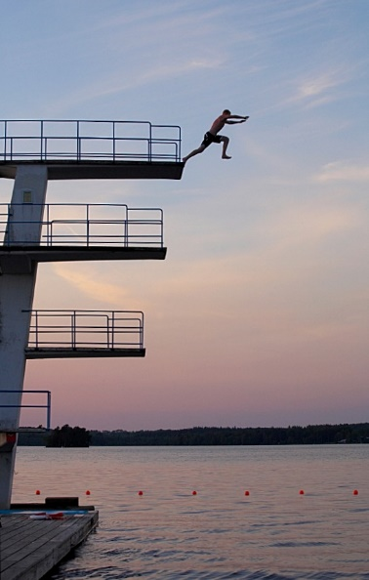

Sincerely,

Coach John Isbell

Parent Information Sheet

I have read the parent letter, syllabus and FBISD policies.

(Parent Signature)

# Contact Information: PLEASE PRINT!

Name: ___________________________________________________________

Home Phone: ____________________ Work Phone: ____________________

Parent Email: ______________________________________________________

Best time to call: ___________________________________________________

🗹 Best way to contact: 🞎 e-mail 🞎 telephone

My child has Internet access: _____ yes ______ no

**Swimmer :**

I, ___________________________, have read the Syllabus, Team rules, FBISD Policies and understand that there will be consequences taken for any infraction. Either at a Swim/Dive Meet or any FBISD Match or function.

Print Swimmer Full Name __________________________________

Swimmer Signature ________________________________